

Under the Guidance of
ASHISH SIR

SESSION: 2025-26

Submitted By
Ansh Mahapatra
Reg No. RU-25-11685

RUNGTA INTERNATIONAL SKILLS
UNIVERSITY
BHILAI ,
CG
File Compression Simulator

(
Using Core Java & OOP Concepts
)
RU-100-01-00012

Object Oriented Programming With Java
Project Interim Report

On
Bachelor of Technology in Computer Science &
Engineering with AI and ML in association with IBM
SCHOOL OF COMPUTER SCIENCE AND E
NGINEERING

(
April
2026)

WEATHER MONITERING SYSTEM

The Weather Monitoring System is a console-based Java application developed using core Java and object-oriented programming concepts. The purpose of this project is to monitor basic environmental parameters such as temperature and humidity and generate alerts based on predefined conditions.
This system is useful in understanding how real-world weather monitoring systems function by analyzing data and providing notifications when certain thresholds are exceeded. The application takes user input for temperature and humidity, processes the data, and generates alerts such as high temperature, low temperature, or high humidity warnings.
The project demonstrates the use of OOP principles like encapsulation, constructors, and methods along with conditional statements to implement decision-making logic. It helps in improving programming skills and understanding practical applications of Java.

Introduction

Weather monitoring plays an important role in daily life as it helps people prepare for environmental conditions. This project simulates a simple weather monitoring system that tracks temperature and humidity and generates alerts accordingly.
The system is designed using Java and follows object-oriented programming principles. It allows users to input weather data and receive alerts based on conditions such as extreme temperature or high humidity.
Key features include:
- Input of temperature and humidity
- Automatic alert generation
- Display of weather report

Objectives

- To design a weather monitoring system using Java
- To store and manage weather data
- To apply conditional logic for generating alerts
- To understand real-world applications of OOP
- To improve problem-solving skills

Scope

This project is suitable for basic weather monitoring simulations and educational purposes. It can be extended in the future by integrating databases, adding multiple records, or connecting to real-time weather APIs.

System Requirements
Hardware: Computer with 4GB RAM
Software: Java JDK, IDE (VS Code / Eclipse)

Methodology

- The system works in the following steps:
- User enters temperature and humidity values
- A WeatherData object is created
- The system checks conditions using if-else logic
- Alerts are generated based on thresholds
- Final weather report is displayed

Flowchart

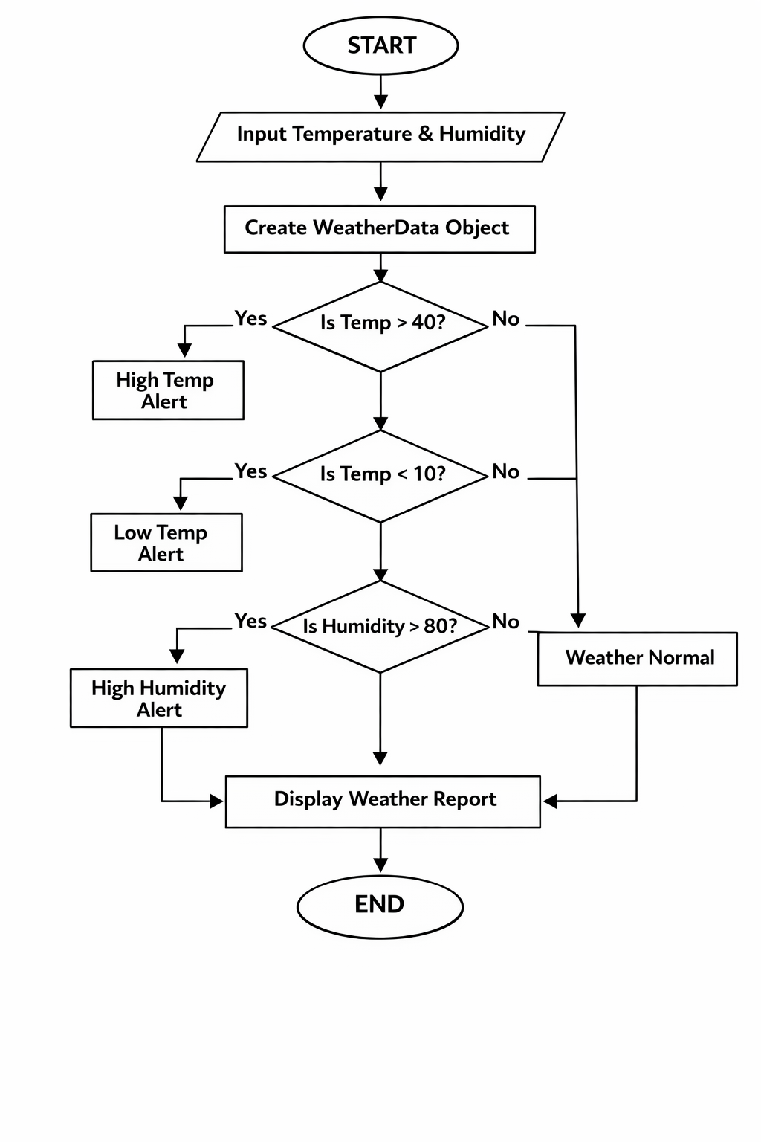

- Class: WeatherData
- Variables:
- temperature (double)
- humidity (double)
- Methods:
- Constructor
- checkAlert()
- displayReport()

Implementation
The project consists of two main classes:
- WeatherData Class
This class stores temperature and humidity as private variables. It uses a constructor to initialize values and contains methods to check alert conditions and display the weather report.
- Main Class (WeatherApp)
This class handles user input using Scanner and creates an object of WeatherData. It calls methods to analyze data and display results.
The alert logic is implemented using conditional statements:
- If temperature > 40 → High Temperature Alert
- If temperature < 10 → Low Temperature Alert
- If humidity > 80 → High Humidity Alert

Gantt Chart

Task | Start Day | End Day | Duration
Planning & Design | Day 1 | Day 1 | 1 Day
Coding (Implementation) | Day 2 | Day 2 | 2 Days
Testing | Day 3 | Day 3 | 1 Day
Report Writing | Day 4 | Day 4 | 1 Day

Conclusion
The project successfully demonstrates the use of Java and object-oriented programming concepts. It provides a functional system that analyzes weather conditions and generates alerts. The project enhances understanding of real-world applications of programming..

References
[1] H. Schildt, Java: The Complete Reference, 11th ed.
[2] Oracle, "Java Documentation," https://docs.oracle.com

Website

[1] Oracle, "Java Documentation," Oracle. [Online]. Available: https://docs.oracle.com
[2] GeeksforGeeks, "Java OOP Concepts," GeeksforGeeks. [Online]. Available: https://www.geeksforgeeks.org/object-oriented-programming-oops-concept-in-java/
[3] Tutorialspoint, "Java Basic Syntax," Tutorialspoint. [Online]. Available: https://www.tutorialspoint.com/java/java_basic_syntax.htm

Conference Paper

[4] S. Kumar, "Application of Java in Real-Time Systems," in Proc. IEEE Conf. on Computing, 2021, pp. 120-125.

Journal Article

[5] A. Sharma and R. Gupta, "Use of Object-Oriented Programming in Software Development," International Journal of Computer Science, vol. 5, no. 2, pp. 45-50, 2020.

